General Hospital
TARGET FOLDER

Approved By: | 
 | Position: Facility Manager

Approved By: | 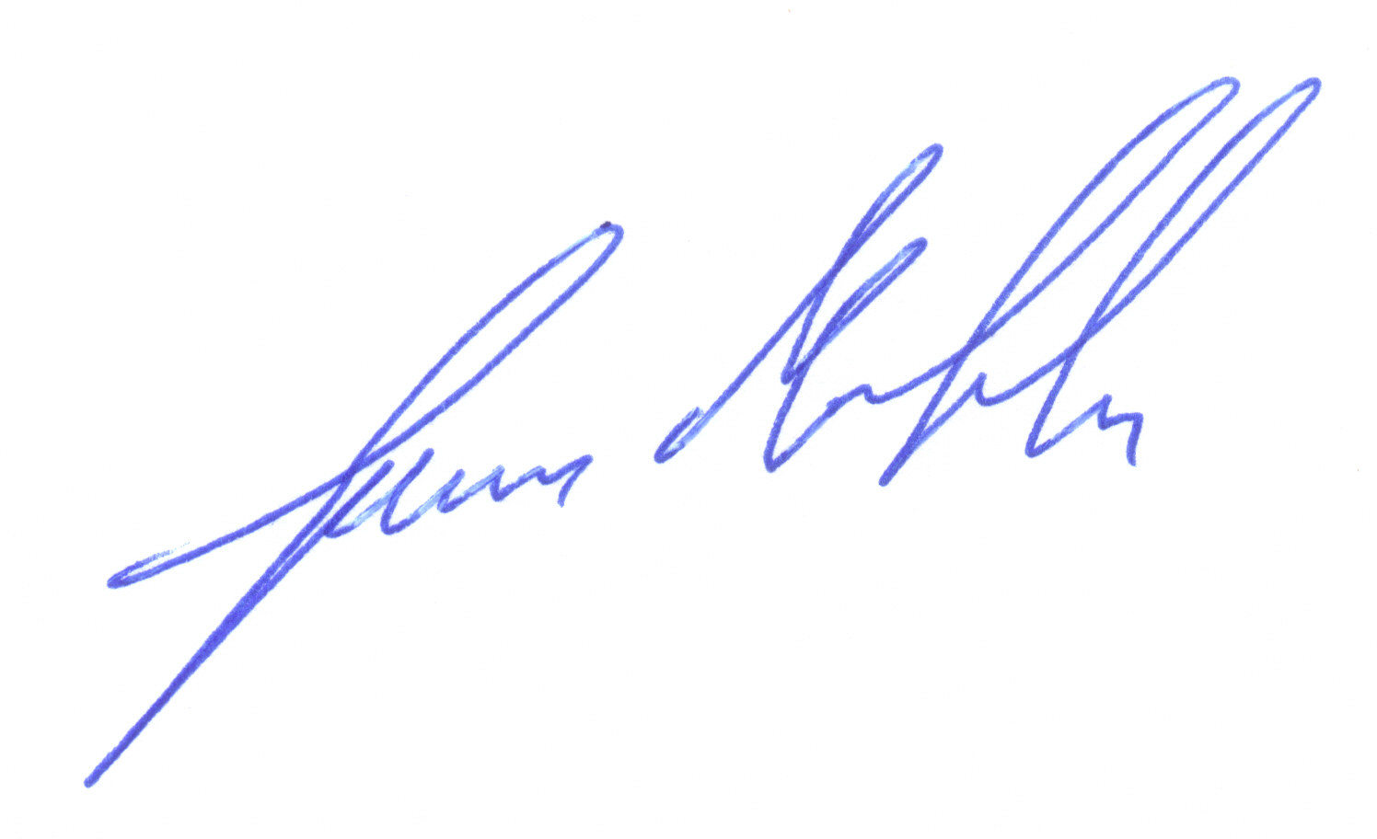
 | Position: Site Security Officer

NOTE: The facility described here within as well as associated documented Target Folder information is hypothetical in nature and provided only to serve as an example of the type and detail of information that should be collected to generate a thorough Target Folder.

Section 1: Facility overview

general site information

Mission

Founded in 1968, General Hospital is a not-for-profit medical center providing comprehensive, emergency, and preventative healthcare for the City of Hillside. The hospital is the only facility in the region that is equipped to provide radiology-based medical services and frequently draws patients from nearby towns.

Location
Hillside is growing metropolis with a population of 900,000 residents. Located at the base of Manzano Peak, the city is surrounded by many small towns (Figure 1). The hospital is conveniently located just east of major interstate. There are many small, independently-owned medical practices surrounding the hospital (Figure 2).
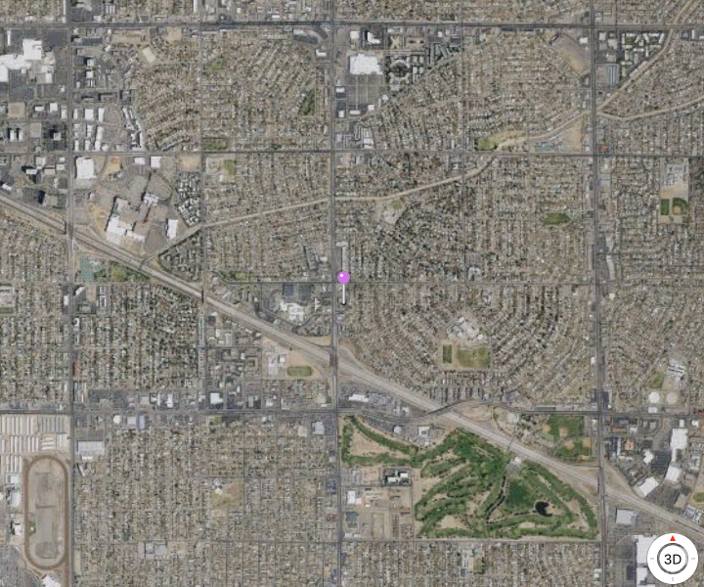

Figure 1. Satellite Image of Hillside and Surrounding Towns

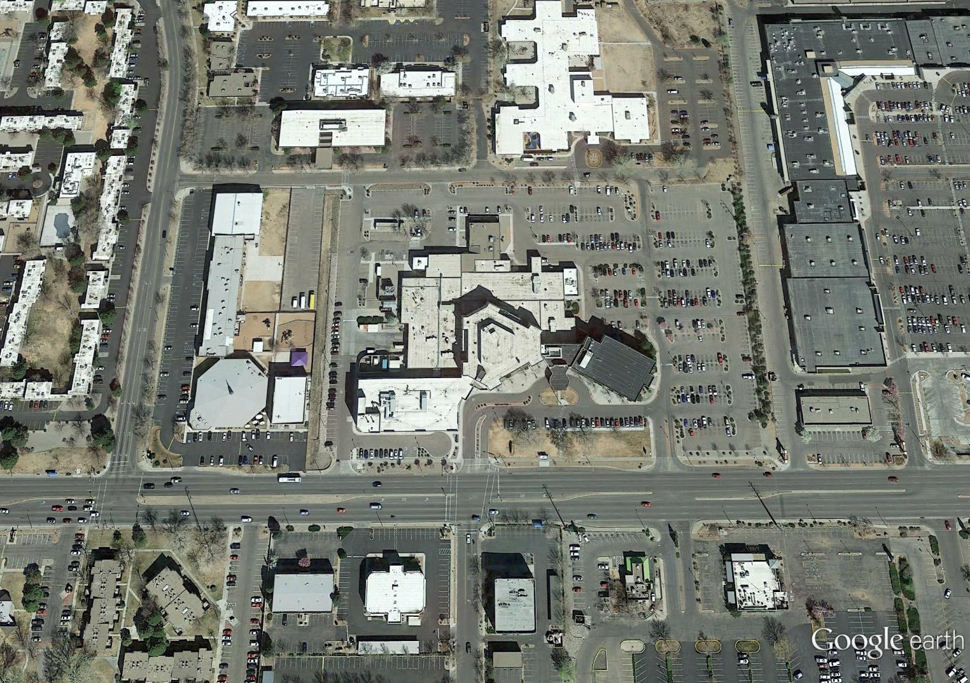

Figure 2. Satellite Image of General Hospital and Surrounding Businesses

staffing
The hospital employs about 250 full-time and part-time employees. The hospital operates 24-hours a day, 365 days a year. Between the hours of 9:00 pm and 5:00 am and on major holidays, the hospital operates with limited staff. Employees work one of three available shifts:
- 0800-1600 hours - 120 Employees
- 1600-0000 hours - 82 Employees
- 0000-0800 hours - 48 Employees

facility description

building construction
General Hospital is a multi-story facility constructed of reinforced concrete (Figure 3 and 4). Both exterior and interior load-bearing walls are comprised of 200mm thick reinforced concrete. Non-load-bearing interior walls are approximately 100 mm thick primarily made up of sheetrock laid over steel framing. The main lobby and the emergency room lobby have a series of half-wall partitions constructed of the same sheetrock over metals studs. Utilities and ventilation run throughout the facility above the false ceiling, which has a gap of 305 mm.
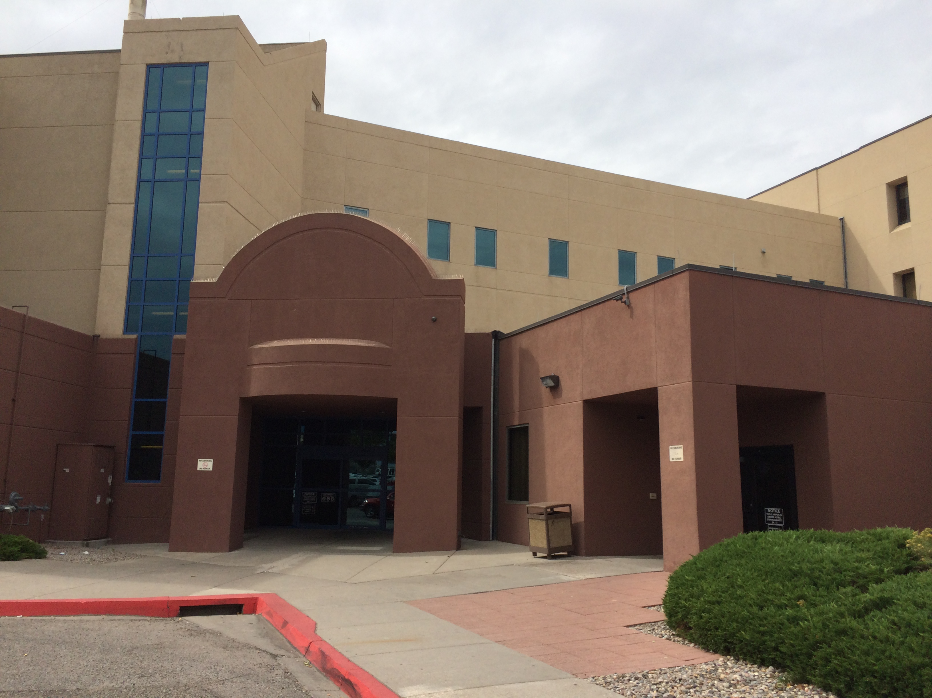
Figure 3. Main Entry of General Hospital

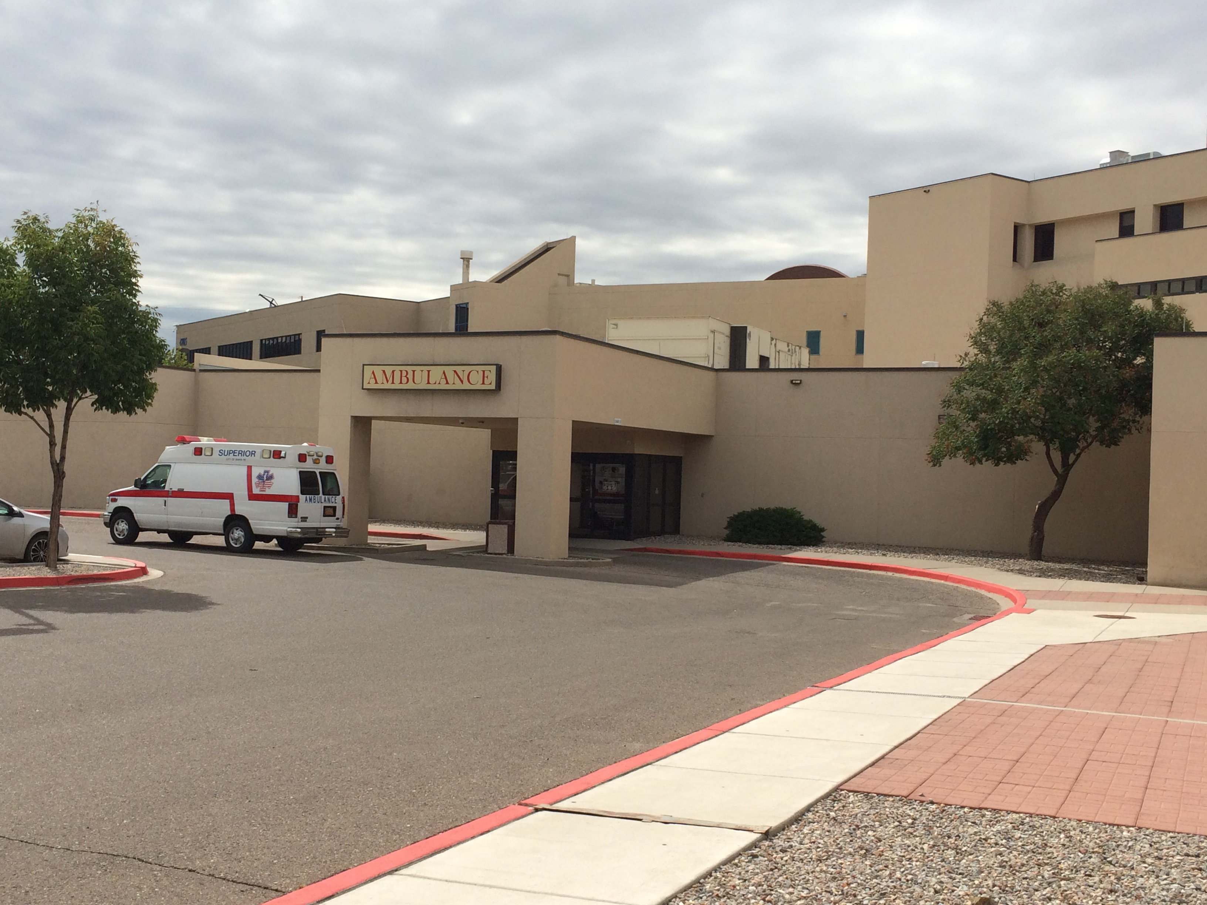
Figure 4. Emergency Entry of General Hospital

Security intrests
General Hospital operates a teletherapy unit to support various oncology treatments. The treatment is accomplished using a GammaBeam® 100-80 unit (Figure 5). The unit is located on the first-floor floor of General Hospital, in the Oncology Department room 1132B . The unit is equipped with a sealed Cobalt-60 (Co-60) source with an approximate activity level of 8,150 curies (301.5 TBq). The source is physically located in the rotatable shielded head. Access to the source can only be accomplished by disassembly of the shielded head. The source weighs approximately 1000 kilograms and can be removed by disassembling the unit. The unit requires infrequent maintenance with source replacement every six years. Re-sourcing is conducted by the GammaBeam manufacturer and requires two technicians using an automated reload machine.
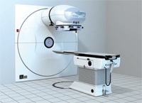
Figure 5. GammaBeam 100-80 Unit
The GammaBeam is located in an isolated room with a single lead-lined steel door providing entry/exit. The room does not have windows. The walls are constructed of 500 mm thick reinforced concrete. When not in use, the door to the treatment room is kept locked. The unit is operated via a specialist using a series of computer controls and cameras. The specialist is located directly outside the treatment room.
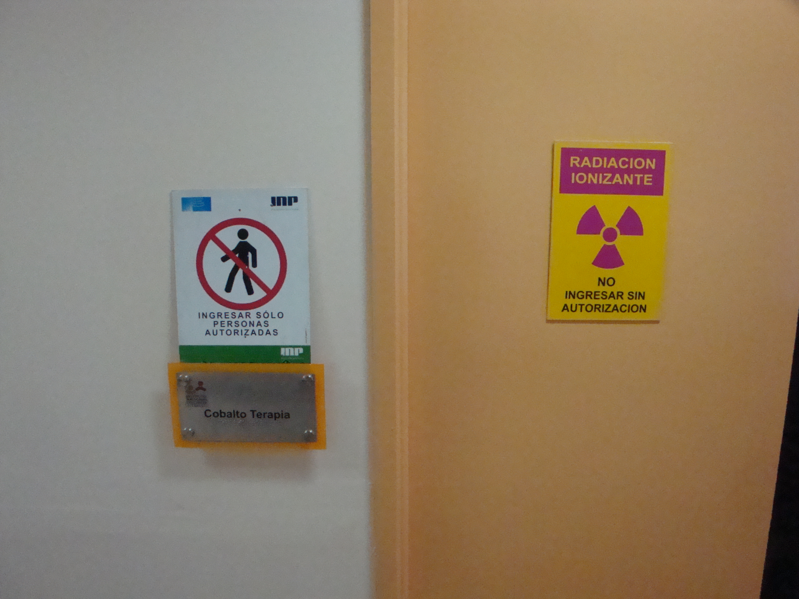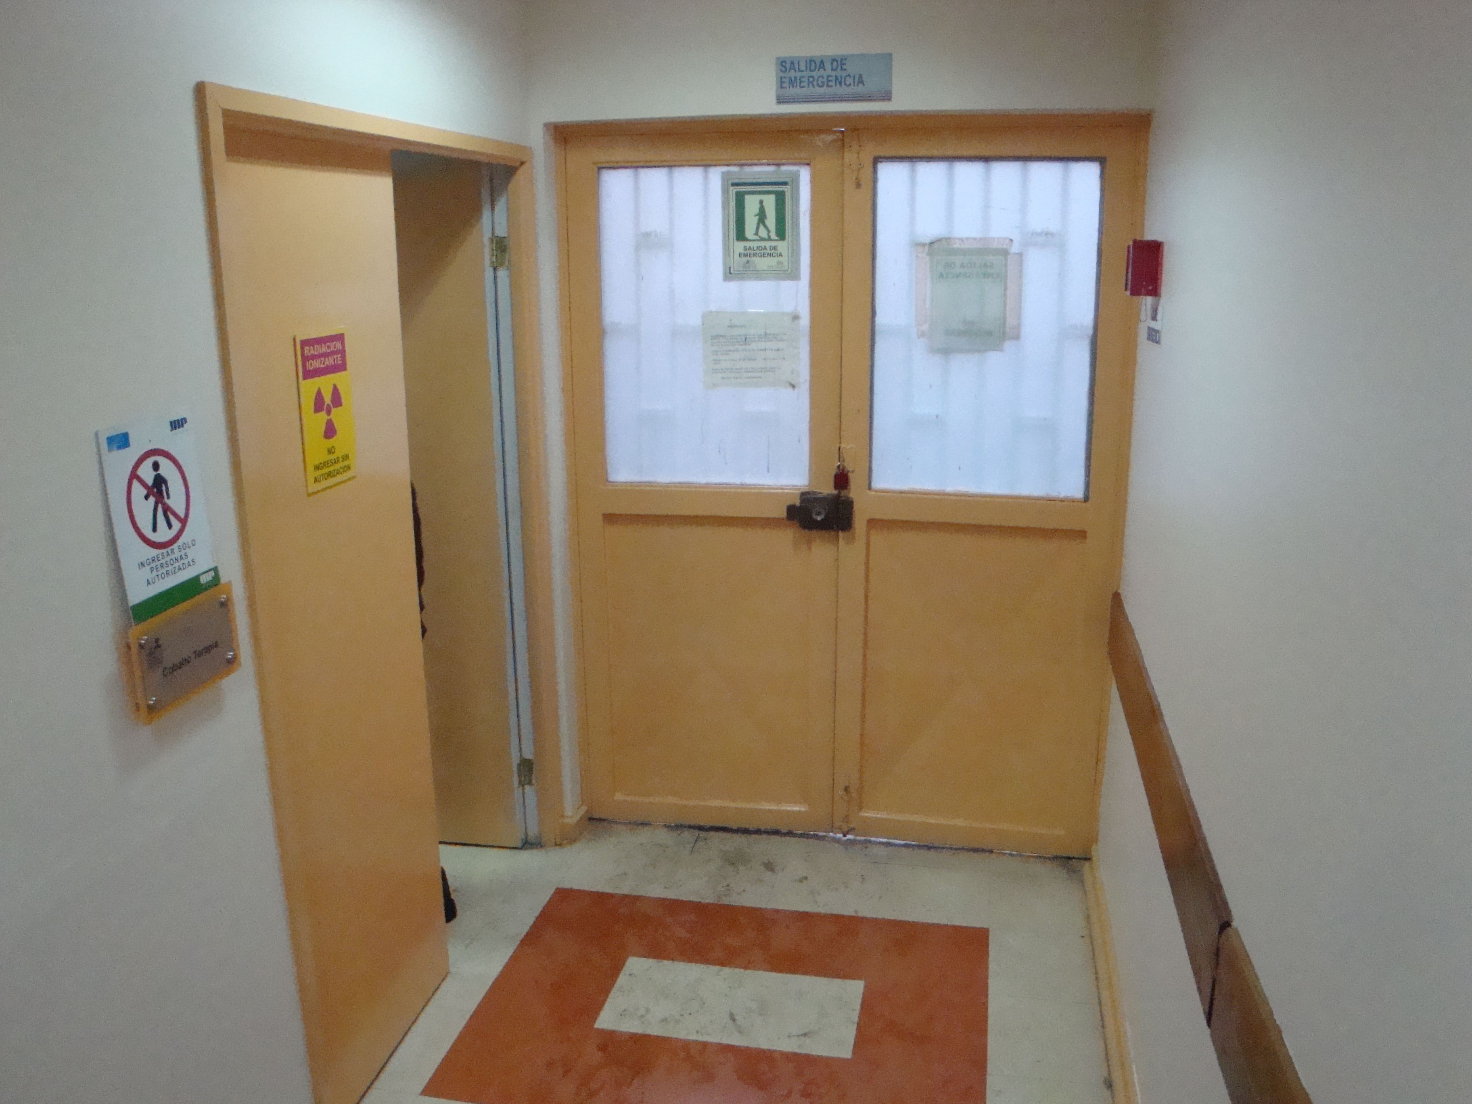
Figure 6. Main Entry Doors to Teletherapy Room
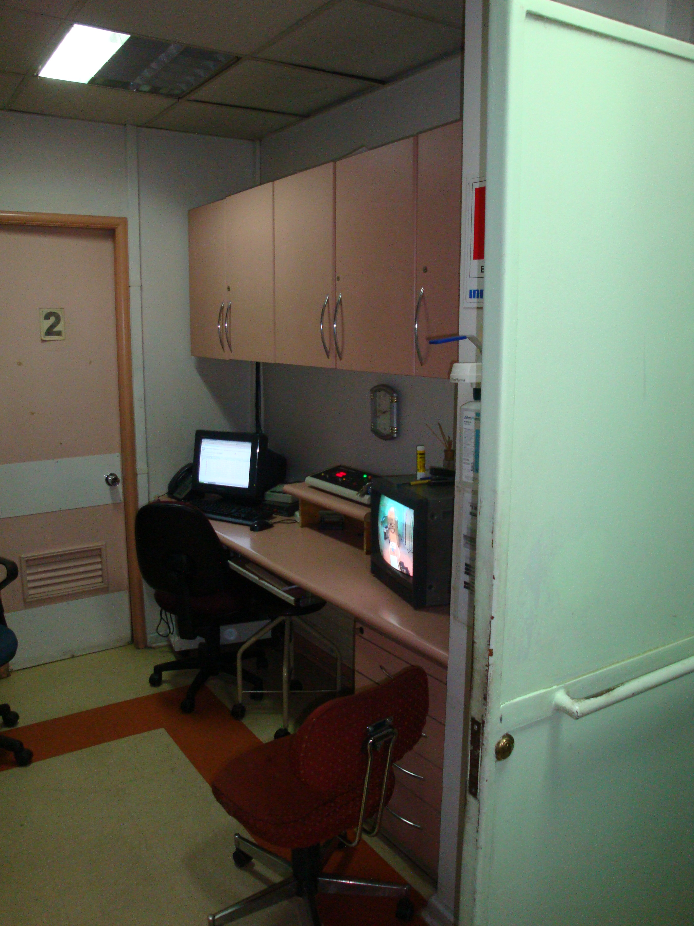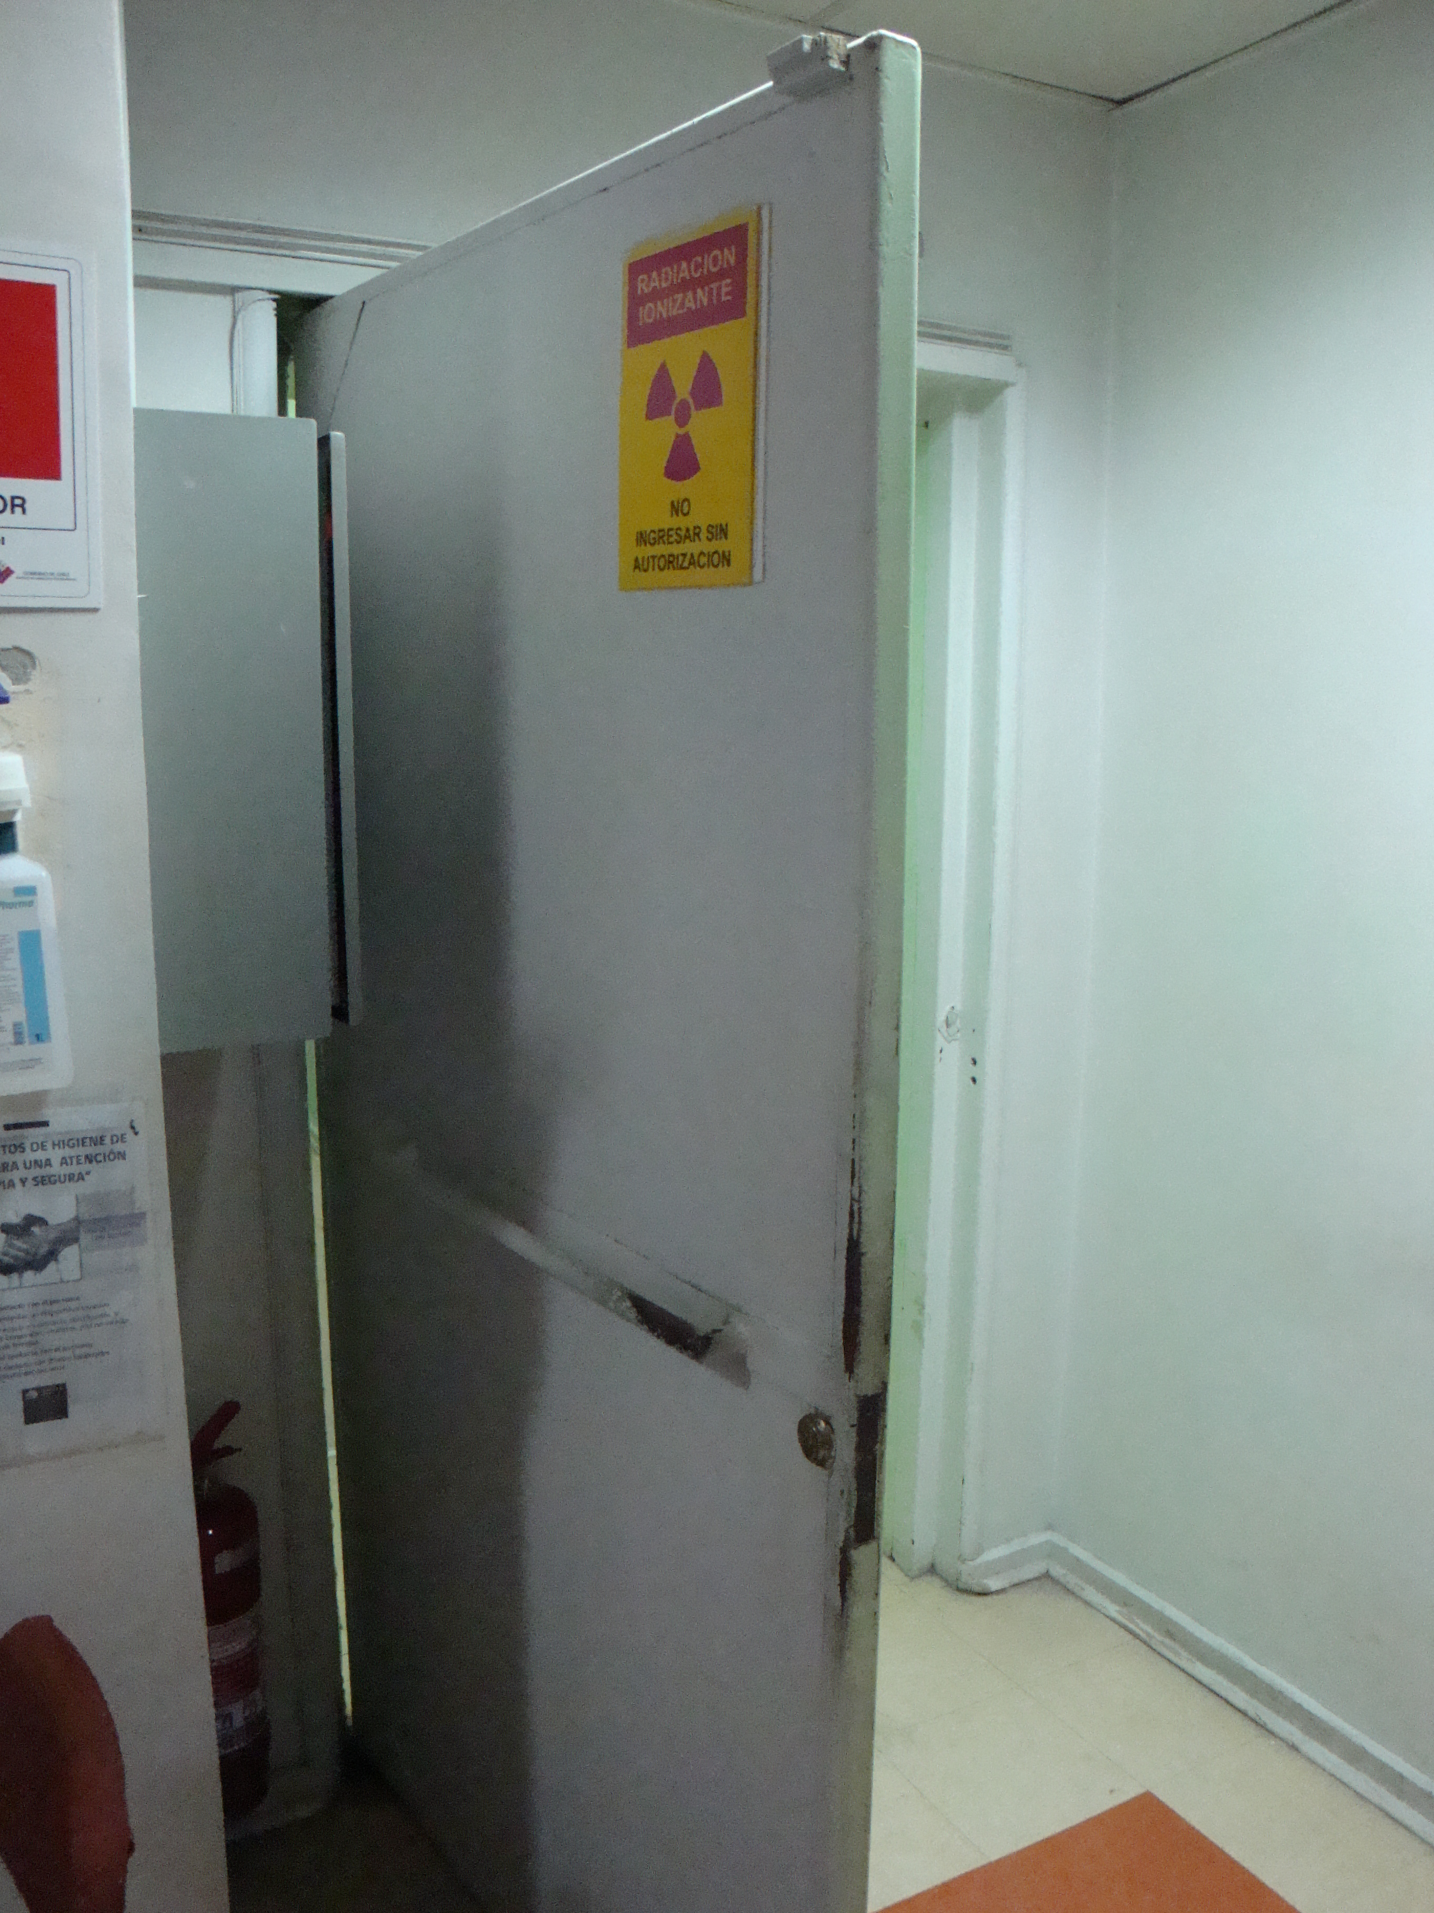
Figure 6. Control Room and Interior Door to Teletherapy Room

protection program description

response forces and missions
General Hospital has a staff of 30 contracted security guards. These individuals are responsible for providing 24-hour alarm response, key control, escorting, and alarm communication to off-site security company with armed responders and local law enforcement, if needed. The following is a breakdown of the number of responders by shift:
- 0800-1600 hrs. 15 unarmed and 4 armed Response Force Members
- 1600-0000 hrs. 6 unarmed and 2 armed Response Force Members
- 0000-0800 hrs. 5 unarmed and 2 armed Response Force Members
Security guards are identified by their issued uniforms and are equipped with radios, flashlights, and batons. ABC Security is a contracted off-site security company with radio dispatched armed response force teams. ABC Security has 8 off-site responders who work the three shifts and are responsible for initial response to hospital alarms and threats to the hospital. Per contract, their response time is listed as 5-7 minutes for one 2 man team to arrive at the hospital. Local police will be notified upon approval of site security supervisors’ request.

Security systems

intrusion detection
The teletherapy unit is protected by a radiation detector (Figure 7) mounted to the wall and two passive infrared motion detectors (Figure 8) installed on opposing sides of the room. A balanced magnetic switch is installed on the entry door into the treatment room (Figure 9).
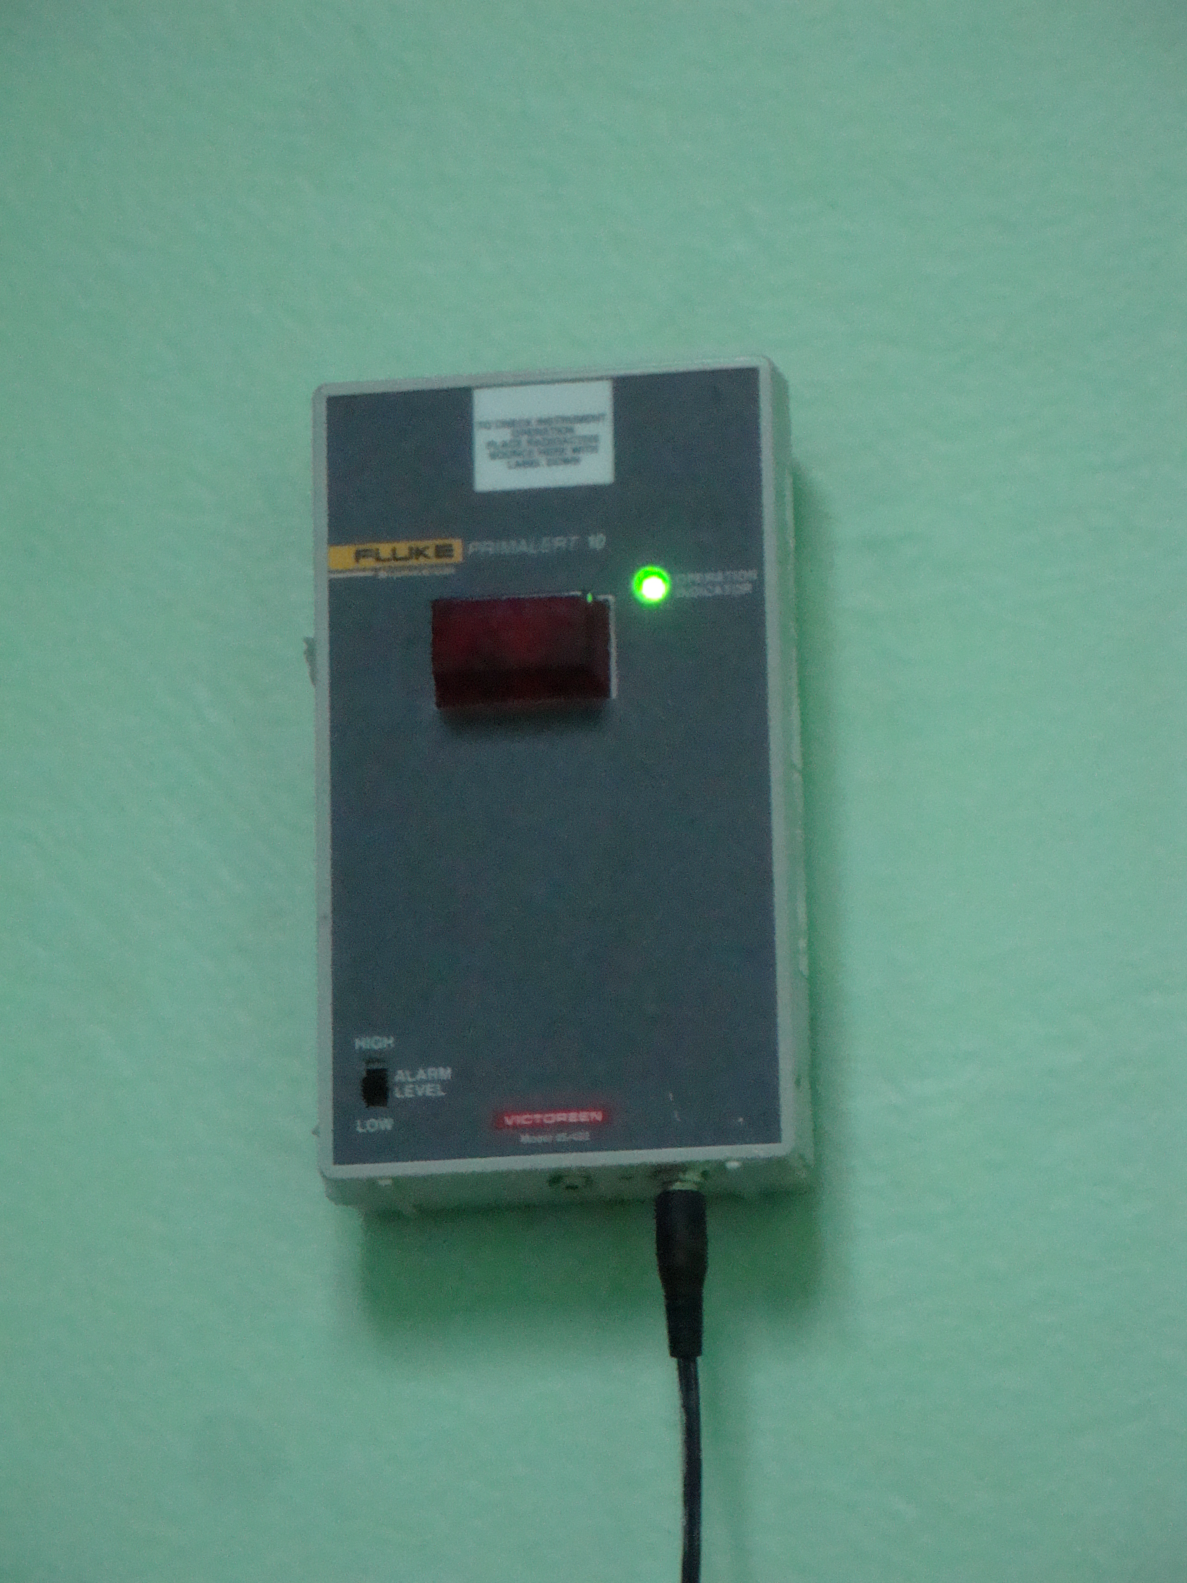
Figure 7. Radiation Detector

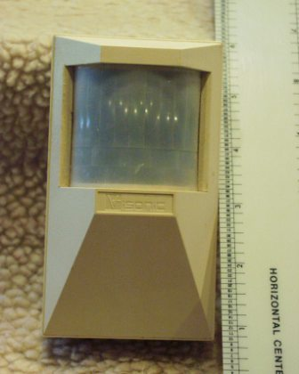
Figure 8. Passive Infrared Motion Detector
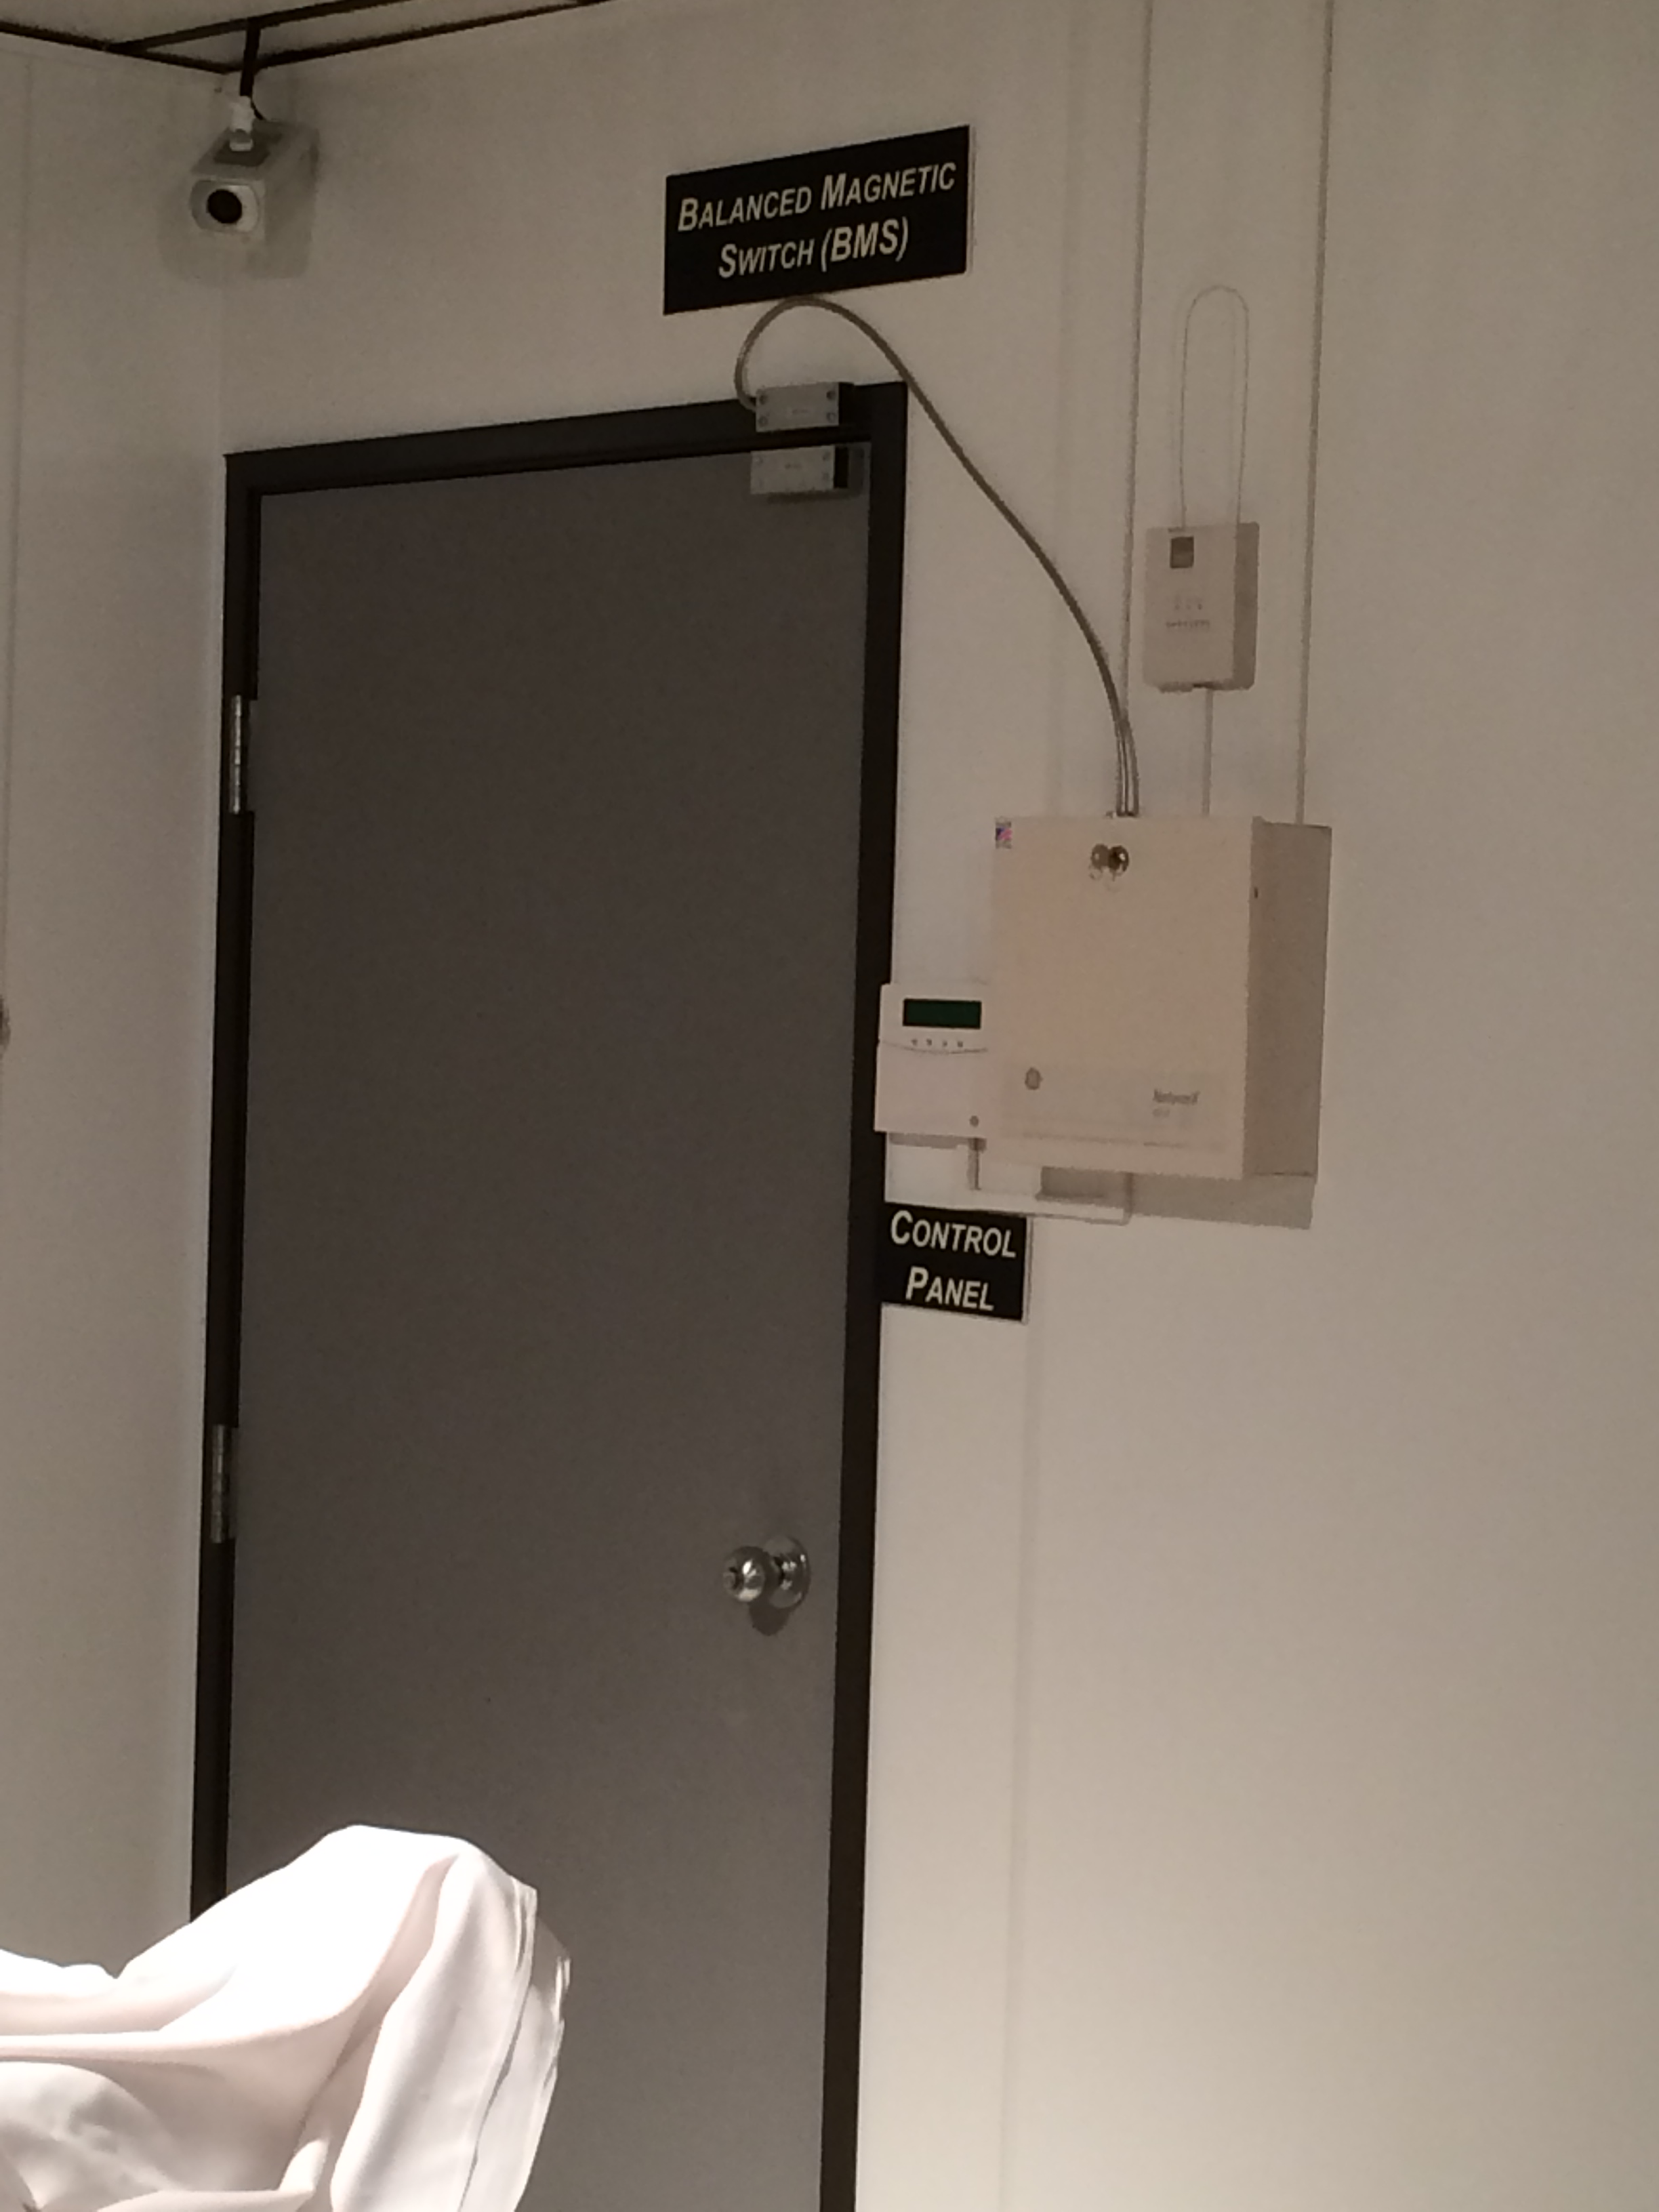

Figure 9. Balance Magnetic Switch

assessment
During administered treatments, the room is monitored by hospital staff via a fixed closed circuit television camera (Figure 10) monitor. The alarm control and display is located at the hospital’s central alarm station (CAS) which is operated 24/7 by the guard force (Figure 11). The CAS has camera coverage of the entry doors and hallway along with the control room. The CAS does not have television coverage of the treatment room to ensure patient privacy.
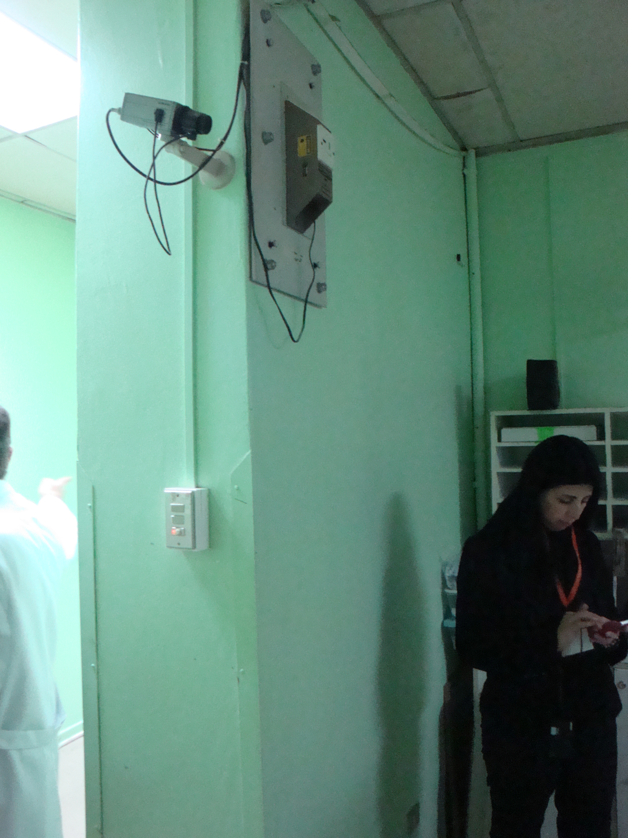
Figure 10. Closed Circuit Television Camera
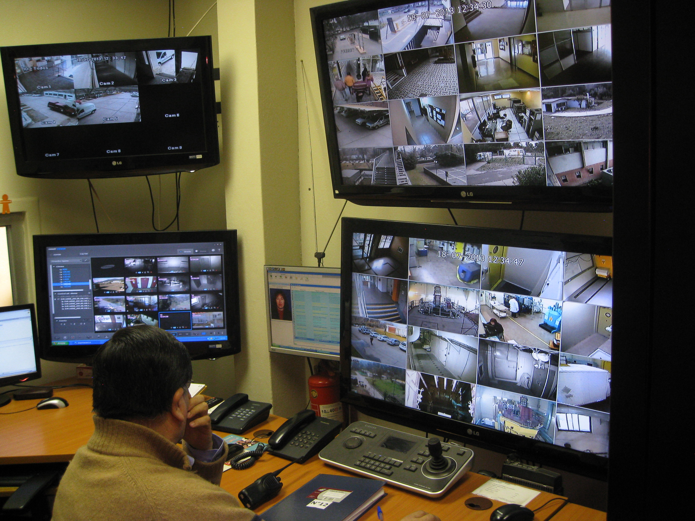
Figure 11. Central Alarm Station

delay
Aside from the lead-lined steel door and standard door lock, there is no additional delay features installed.

Section II: facility layout

floor diagrams
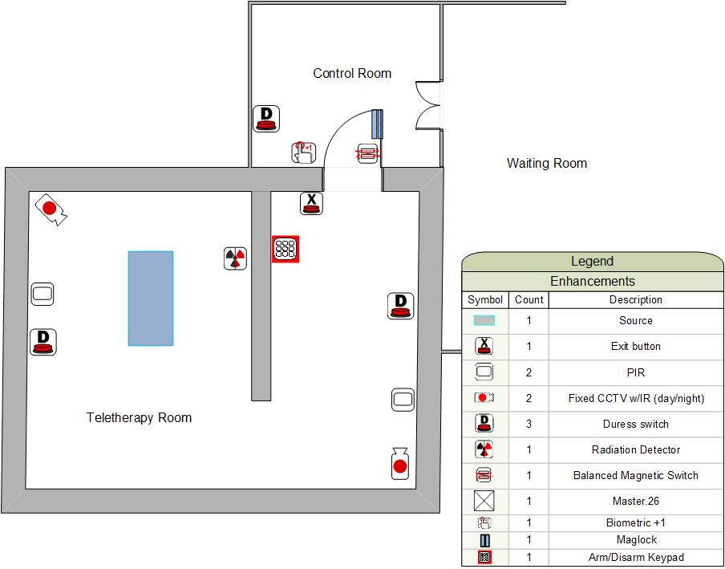

Points of Contact
In the event of an emergency, the following are points of contact for all facilities within this target folder:
General Hospital
- Main Hospital Administration/Main Hospital Operator: 1505 111-2222
- Hospital Security/Central Alarm Station (24/7): 1 505 111-2229
- Hospital Teletherapy Director: Dr. H.M.Schmidt (Office) 1 505 111-2301
(Cell) 1 505 400-1234
ABC Security
- Central Alarm Station (24/7): 1 505 122-2500
- Supervisor direct number: 1 505 122-2505
Radiological Regulator
- Mr. J Rivera (Office) 1 505 XXX-XXXX
(Cell) 1 505 XXX-XXXX
Local Police
- Emergency Number 911
(Local Number) 1 505 333-5555
- Police Hazardous Response: Lt. T Hogan (Office) 1 505 XXX-XXXX
(Cell) 1 505 XXX-XXXX
Local Fire
Hazardous Material Response
Federal Police

